**Final Year B.Tech. (CSE) – II [ 2021-22 ]**

**Cryptograpy and Network Security Lab**

**PRN: 2019BTECS00015**

**Full name: Shraddha Sanjay Kharat**

**Batch: B1**

**Assignment no -1**

**Date: 23-08-2022**

**Que )** **Caesar Cipher implementation**

**Theory:**

The Caesar Cipher technique is one of the earliest and simplest methods of encryption technique. It’s simply a type of substitution cipher, i.e., each letter of a given text is replaced by a letter with a fixed number of positions down the alphabet. For example with a shift of 1, A would be replaced by B, B would become C, and so on. The method is apparently named after Julius Caesar, who apparently used it to communicate with his officials.

Thus to cipher a given text we need an integer value, known as a shift which indicates the number of positions each letter of the text has been moved down.

The encryption can be represented using modular arithmetic by first transforming the letters into numbers, according to the scheme, A = 0, B = 1,…, Z = 25. Encryption of a letter by a shift n can be described mathematically as.

**Code Snapshots:**

#include <iostream>

using namespace std;

string encrypt(string text, int s)

{

    string result = "";

    // traverse text

    for (int i=0;i<text.length();i++)

    {

        // Encrypt Uppercase letters

        if (isupper(text[i]))

            result += char(int(text[i]+s-65)%26 +65);

    // Encrypt Lowercase letters

    else

        result += char(int(text[i]+s-97)%26 +97);

    }

    // Return the resulting string

    return result;

}

int main()

{

    string text;

    int s;

    cout << "Enter Plain Text:";

    cin >> text;

    cout << "Enter Key:";

    cin >> s;

    cout << "Text : " << text;

    cout << "\nShift: " << s;

    cout << "\nCipher: " << encrypt(text, s);

    return 0;

}

**Output:**

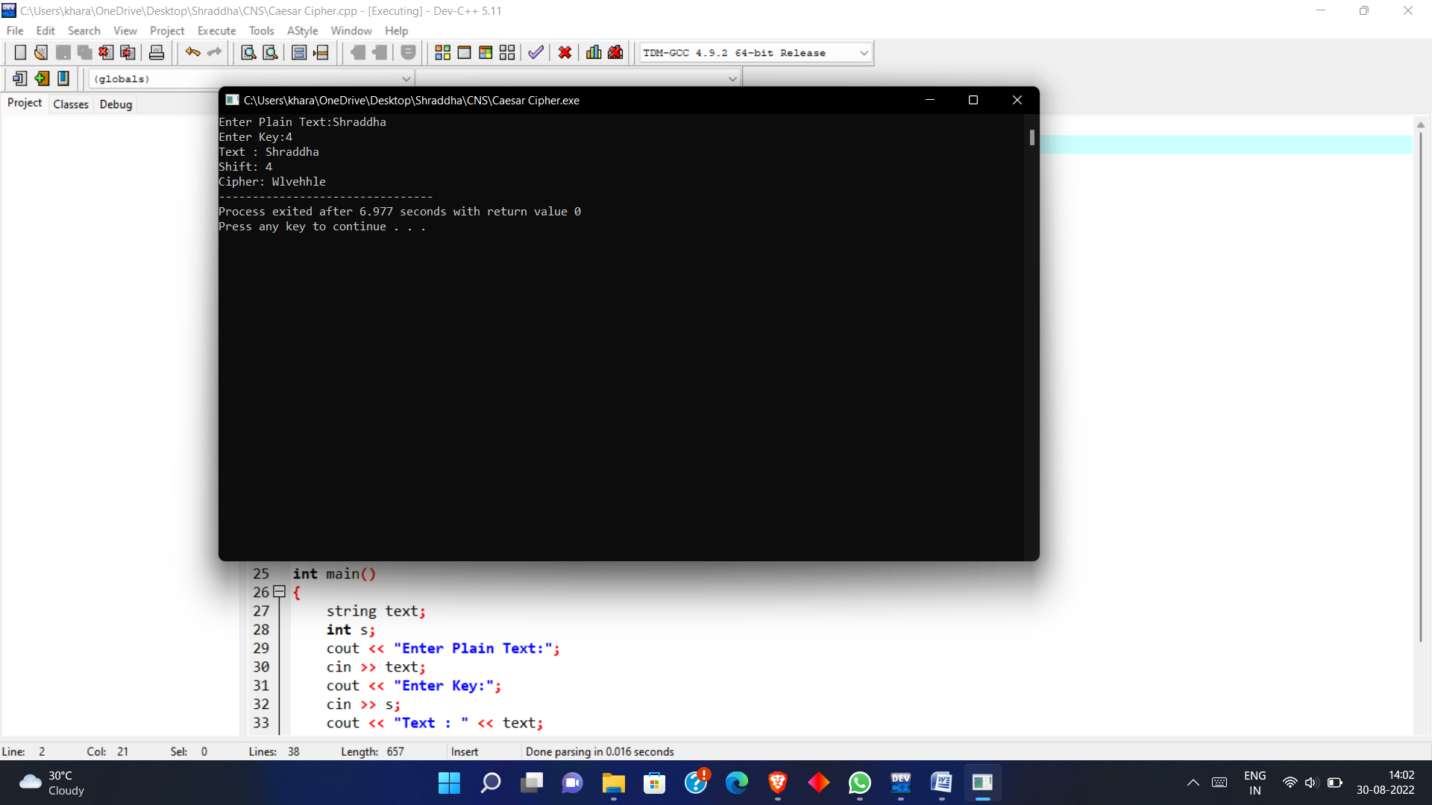

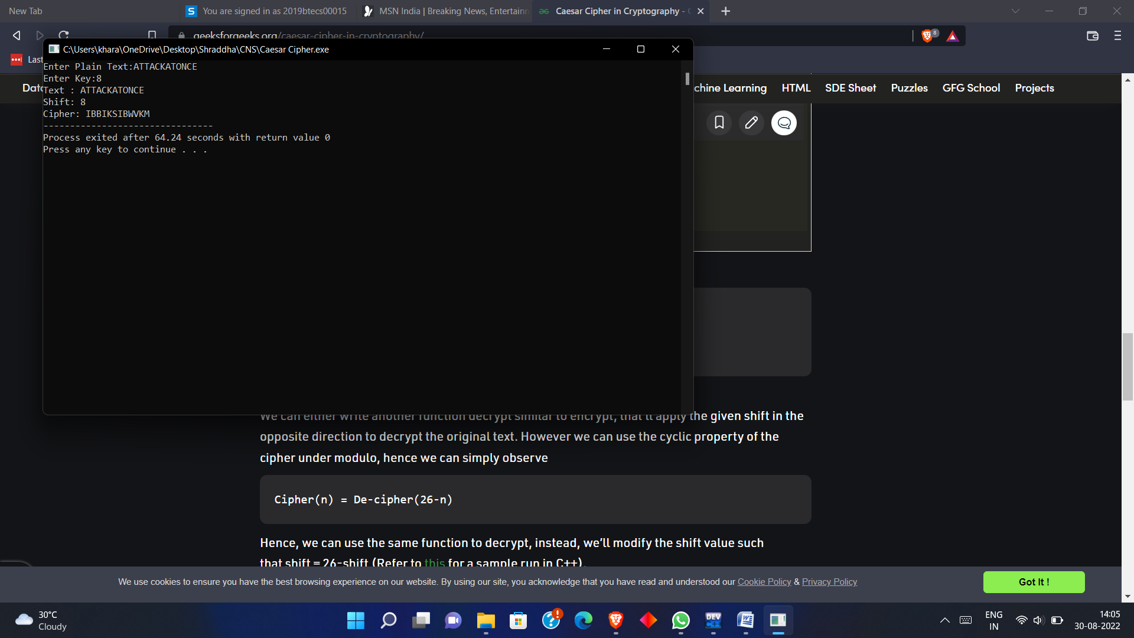

* **Conclusion** :

Caesar Cipher is simple substitution technique. The key can be deciphered easily, thus makes it less secure